Name: Ahmed Mohamed

ID:000397658

Assignment: Step by Step

Prof. Farhan Ahmad

Microsoft Excel: How to create tables and sort its content

Introduction

Microsoft Excel is one of the powerful tools in the Microsoft office suite. It is mainly used in working with data analysis and financial reporting where the user can edit data and present it in different format that meets the audience expectations. In this assignment we will mainly focus on creating tables and sorting its content.

The following section will mention the step by step process of inputting data into tables and how to sort the content of the tables according to the user’s requirement.

Steps and Instructions

1.Saving Excel file

- Open Excel application, it should be on start all programs, Microsoft suite,

Microsoft Excel.

-Choose create a workbook and then click on the top tab where it is called “File”.

-A menu will pop up and you will find the “Save as” option in the “File” Menu.

-Click at “Save as” and a form will pop up as shown in Fig 1.

-Make sure you type the file name and choose where you want to save the file then click save as indicated by the arrow in Fig1.

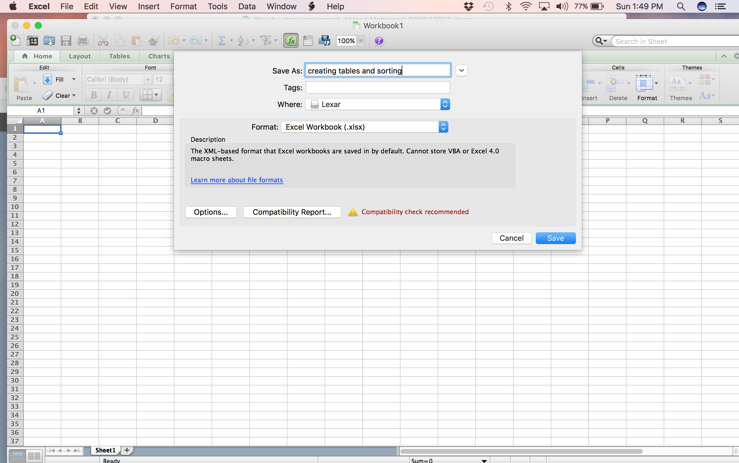

Fig 1: Saving an Excel Workbook file

2.Creating tables in Excel

-Click on the “Tables” tab at the top as shown in Fig 2.

-Find the “New” icon as indicated by the arrow and click on it.

-A column will appear as shown in Fig 3 that inserts a new highlighted

Column in blue will show up.

-The column shown can be expanded and stretched according to the user requirements so it can have a space for more data to input and present.

-To expand the table, click on the circle indicated by the arrow and stretch the circle down till you see the second column as shown in Fig4.

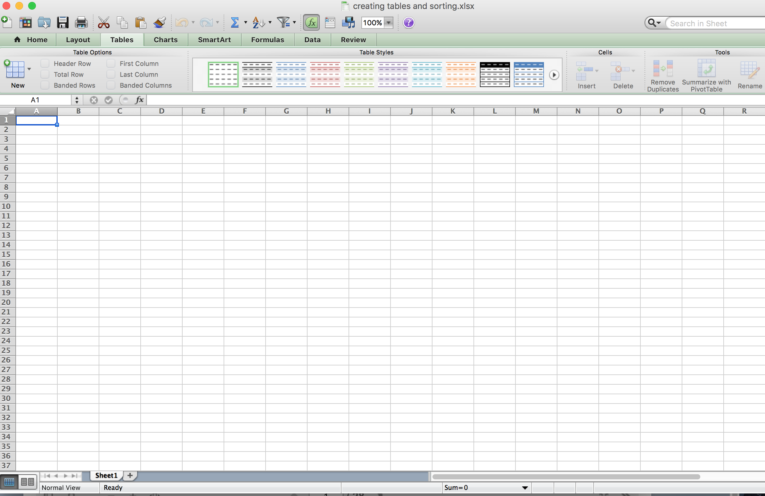

Fig 2: Creating Tables in Excel

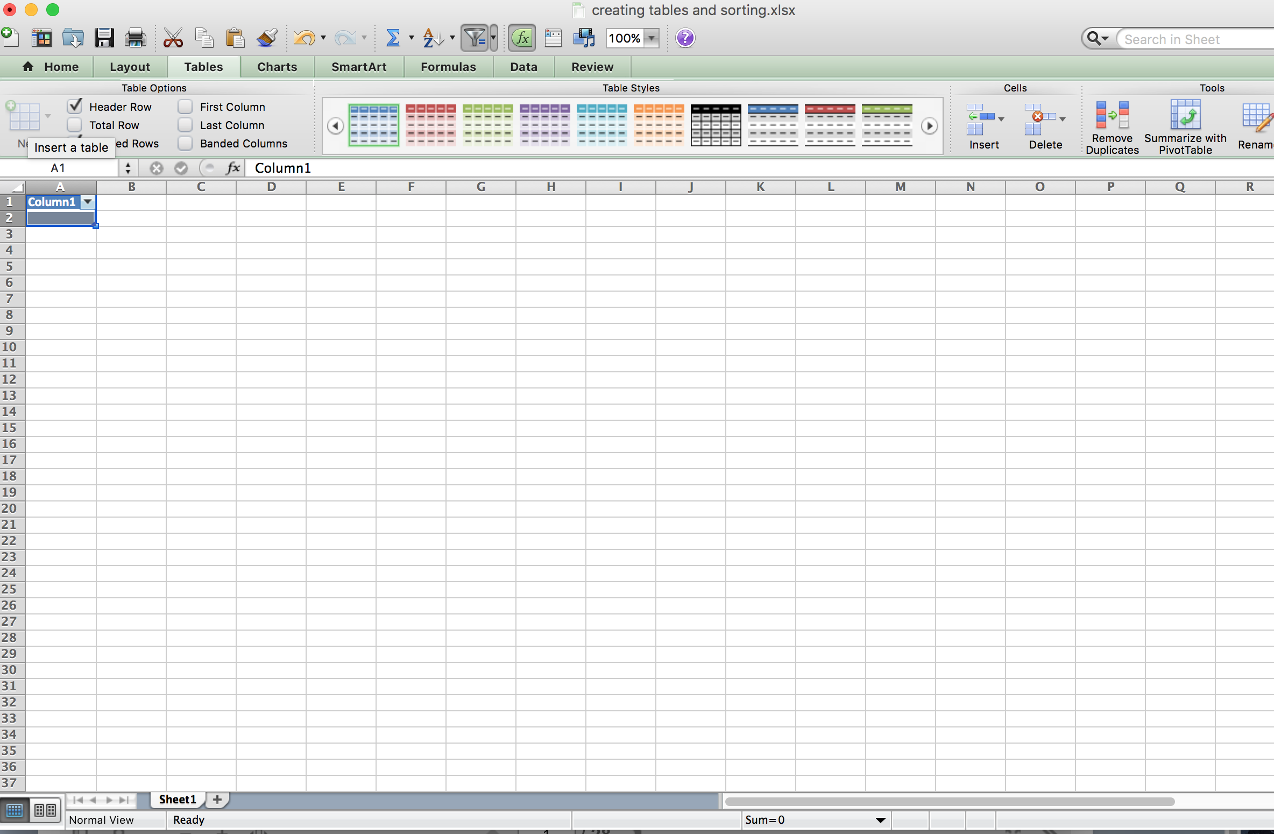

Fig 3: Inserting tables in an Excel Worksheet

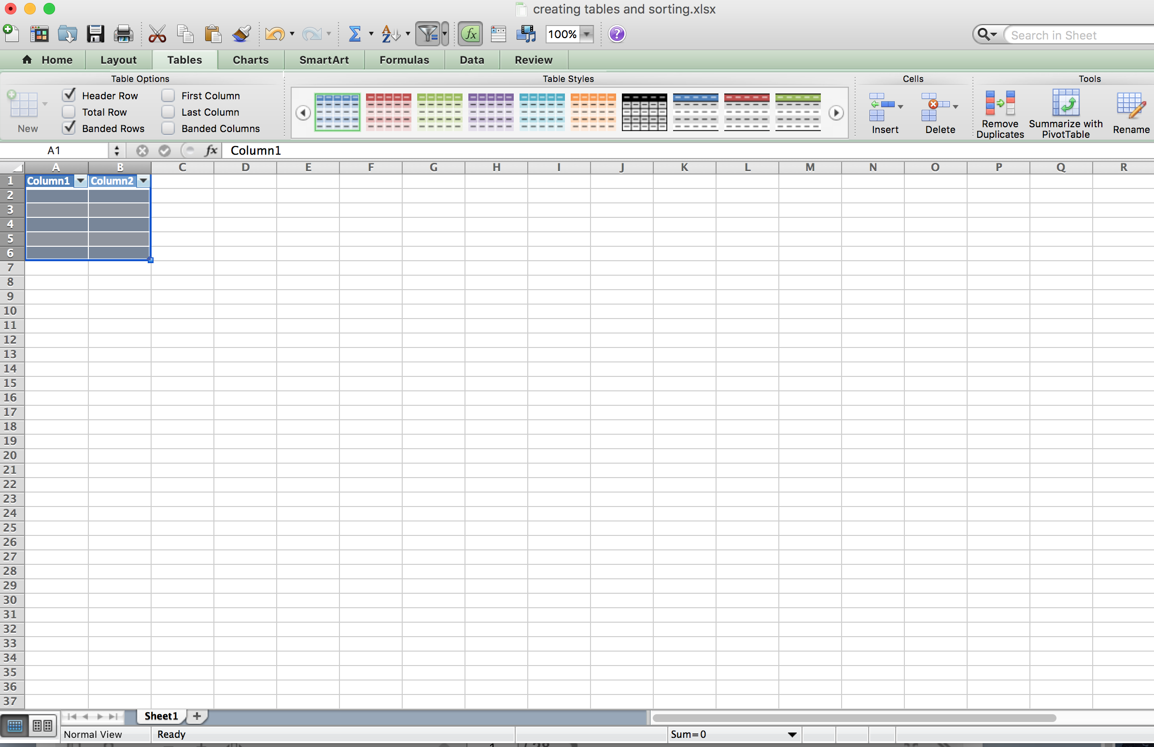

Fig 4: Expanding the table and creating an extra column

3.Data input in Tables in Excel

-Now you have two columns and 6 rows to input data, so click on the column header and name each column.

-In our example we will name one column “Names” and the second column name it “Numbers” as shown in Fig 5. The arrows show the named columns.

-Everything is set to type the data for your table. In the “Names” column we will type 6 names to fill the rows and the same case goes for the “Numbers” column as shown in Fig 6.

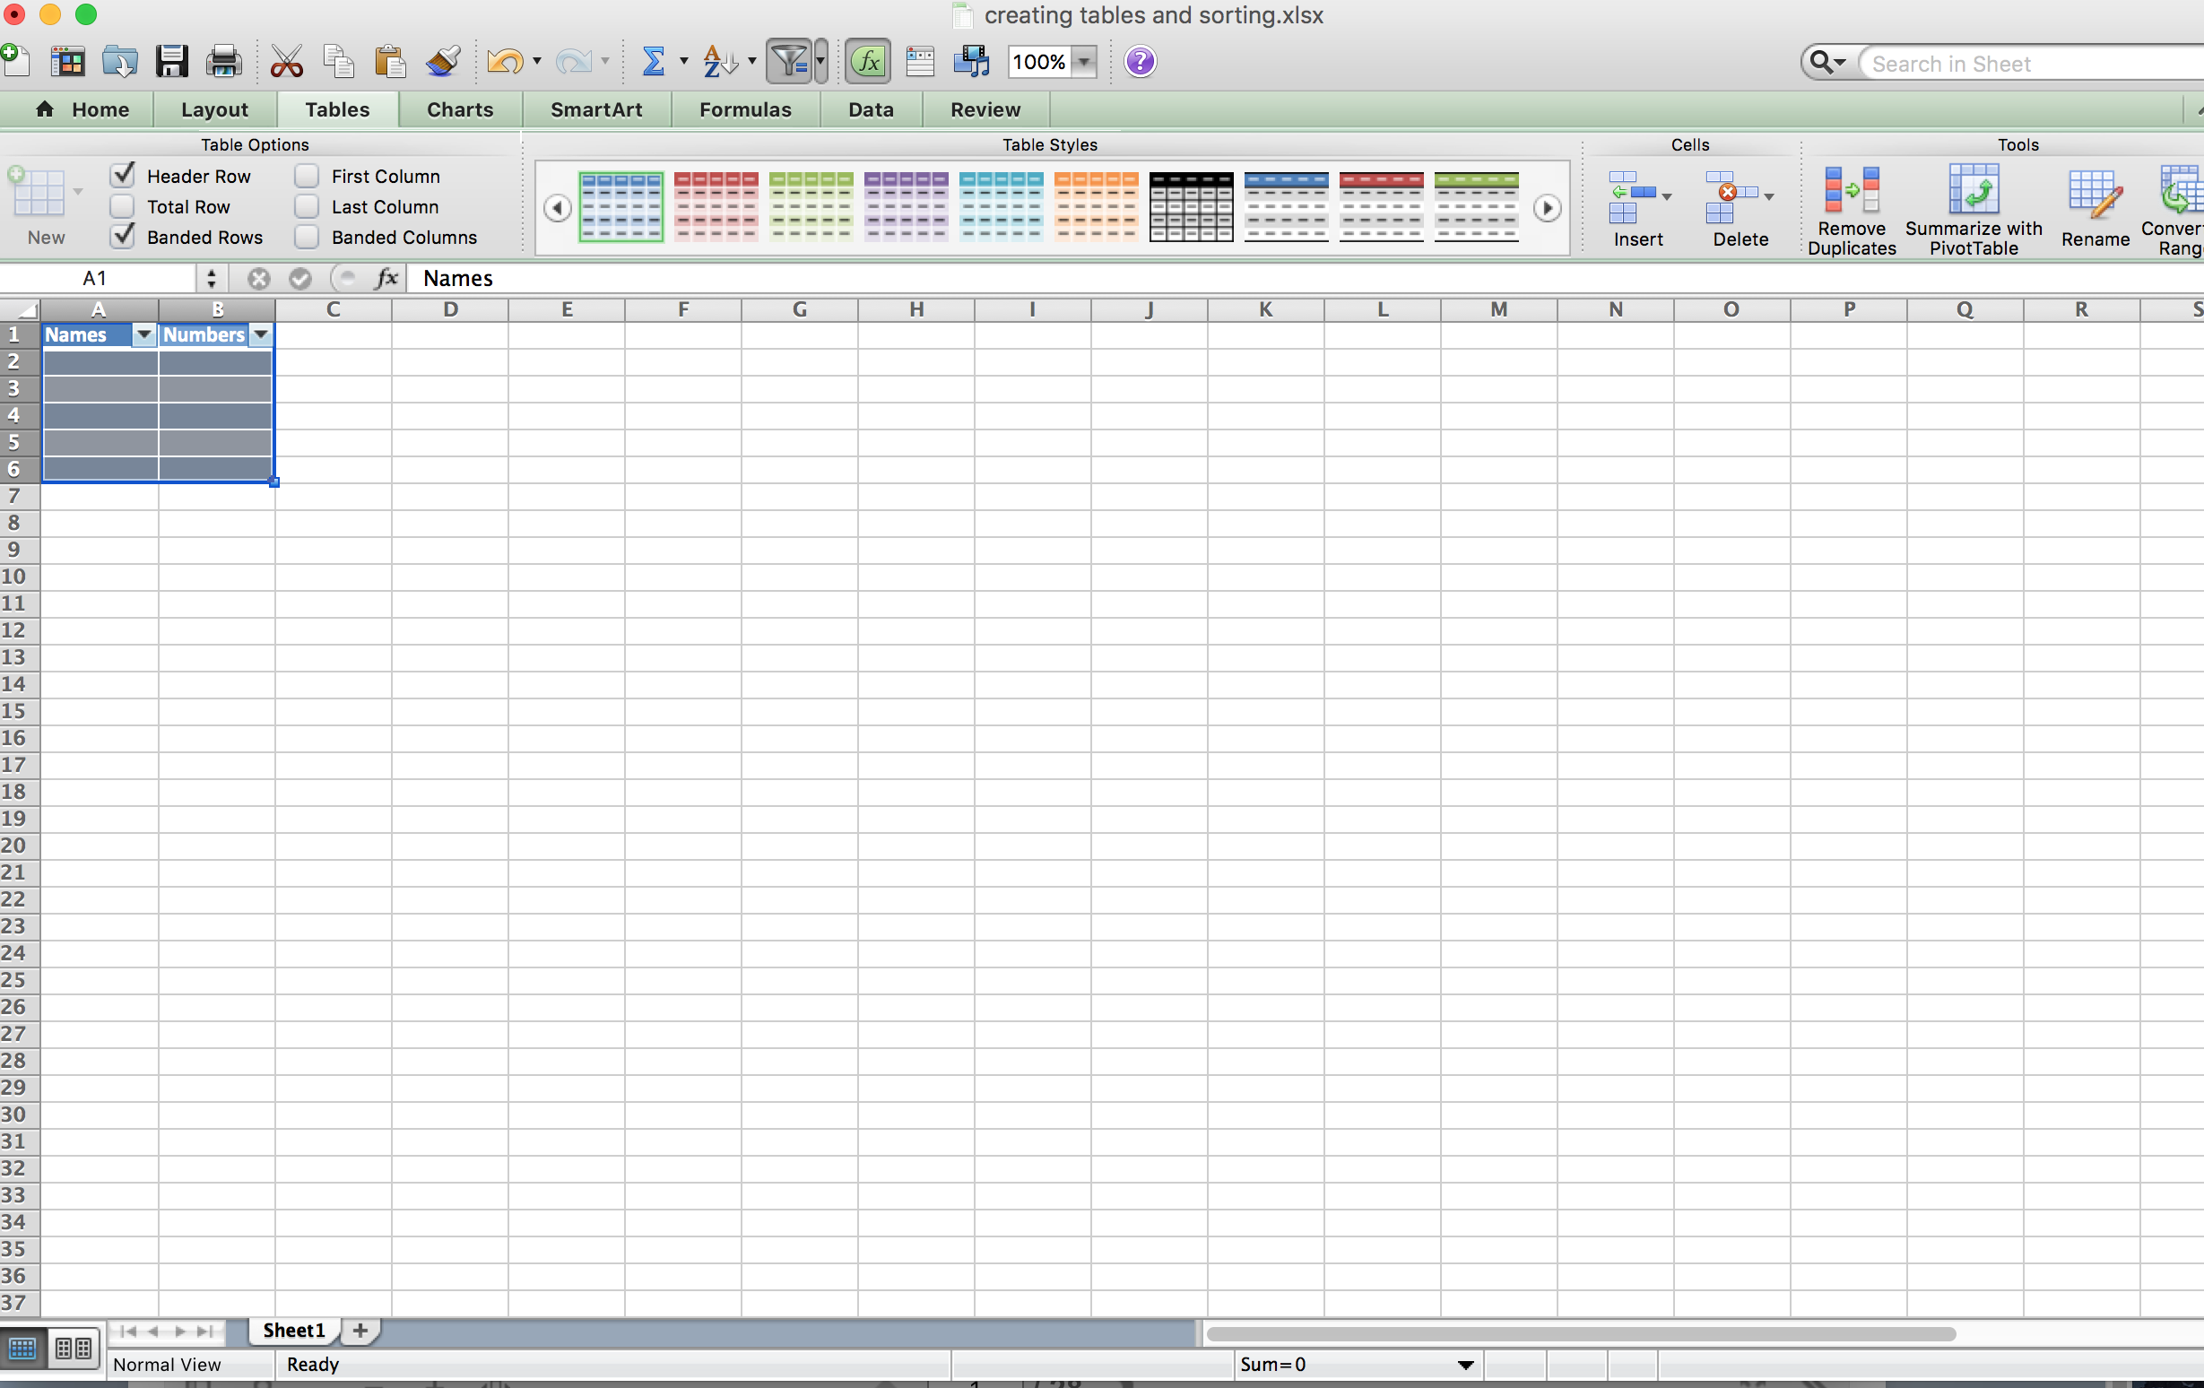

Fig 5: Naming columns in Excel

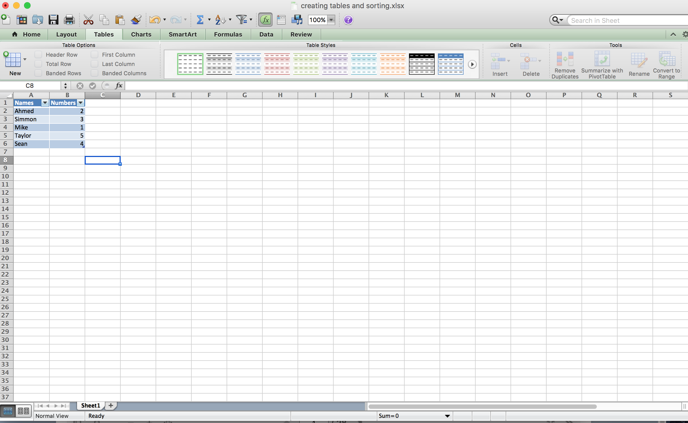

Fig 6: Data input and filling table columns

4. Sorting Tables in Excel

-As shown in Fig 7, you will find the two column headers at the excel sheet table beside each column header you will find a small arrow icon as pointed by the blue arrow.

-Click on the small arrow icon beside the “Names” column and the sorting options will pop up as shown in Fig 8.

-The sorting option in excel allows the user to sort all the data content inside the table created and once you select a certain data to show inside the table, it will be displayed and the data corresponds to it in the other table will be seen (as shown in Fig 9).

-The sorting option can still go beyond and you can sort search for a specific data that “Begin with”, ”End with” or “Contains” a certain character or number (As shown in Fig 10).

-In our example, we will display names that begin with the “S”. So click on “Begins with” icon and type “S” at the search bar in the “Filter” option indicated by the arrow. The results will be displayed (as shown in Fig 11).

-Another sorting option that we should mention is sorting data in ascending and descending order. In order to use that option, click on clear filter then click on the ascending button option (as shown in Fig 12). The data displayed will show the “Names” column sorted out in ascending order with the corresponding data in the “Numbers” column. The same method works with descending order button.

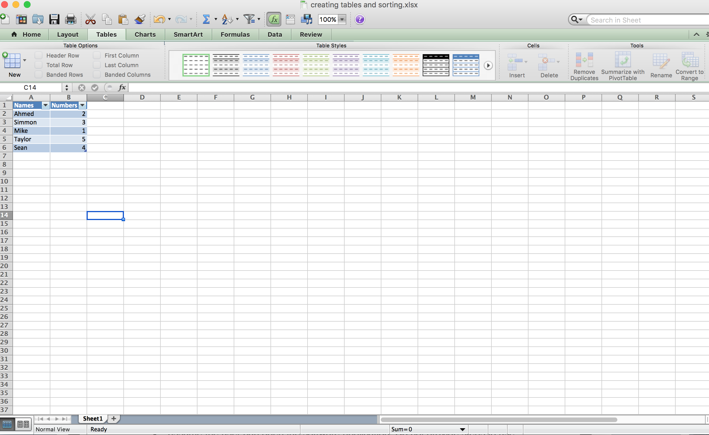

Fig 7: Sorting table content in excel using the sort option

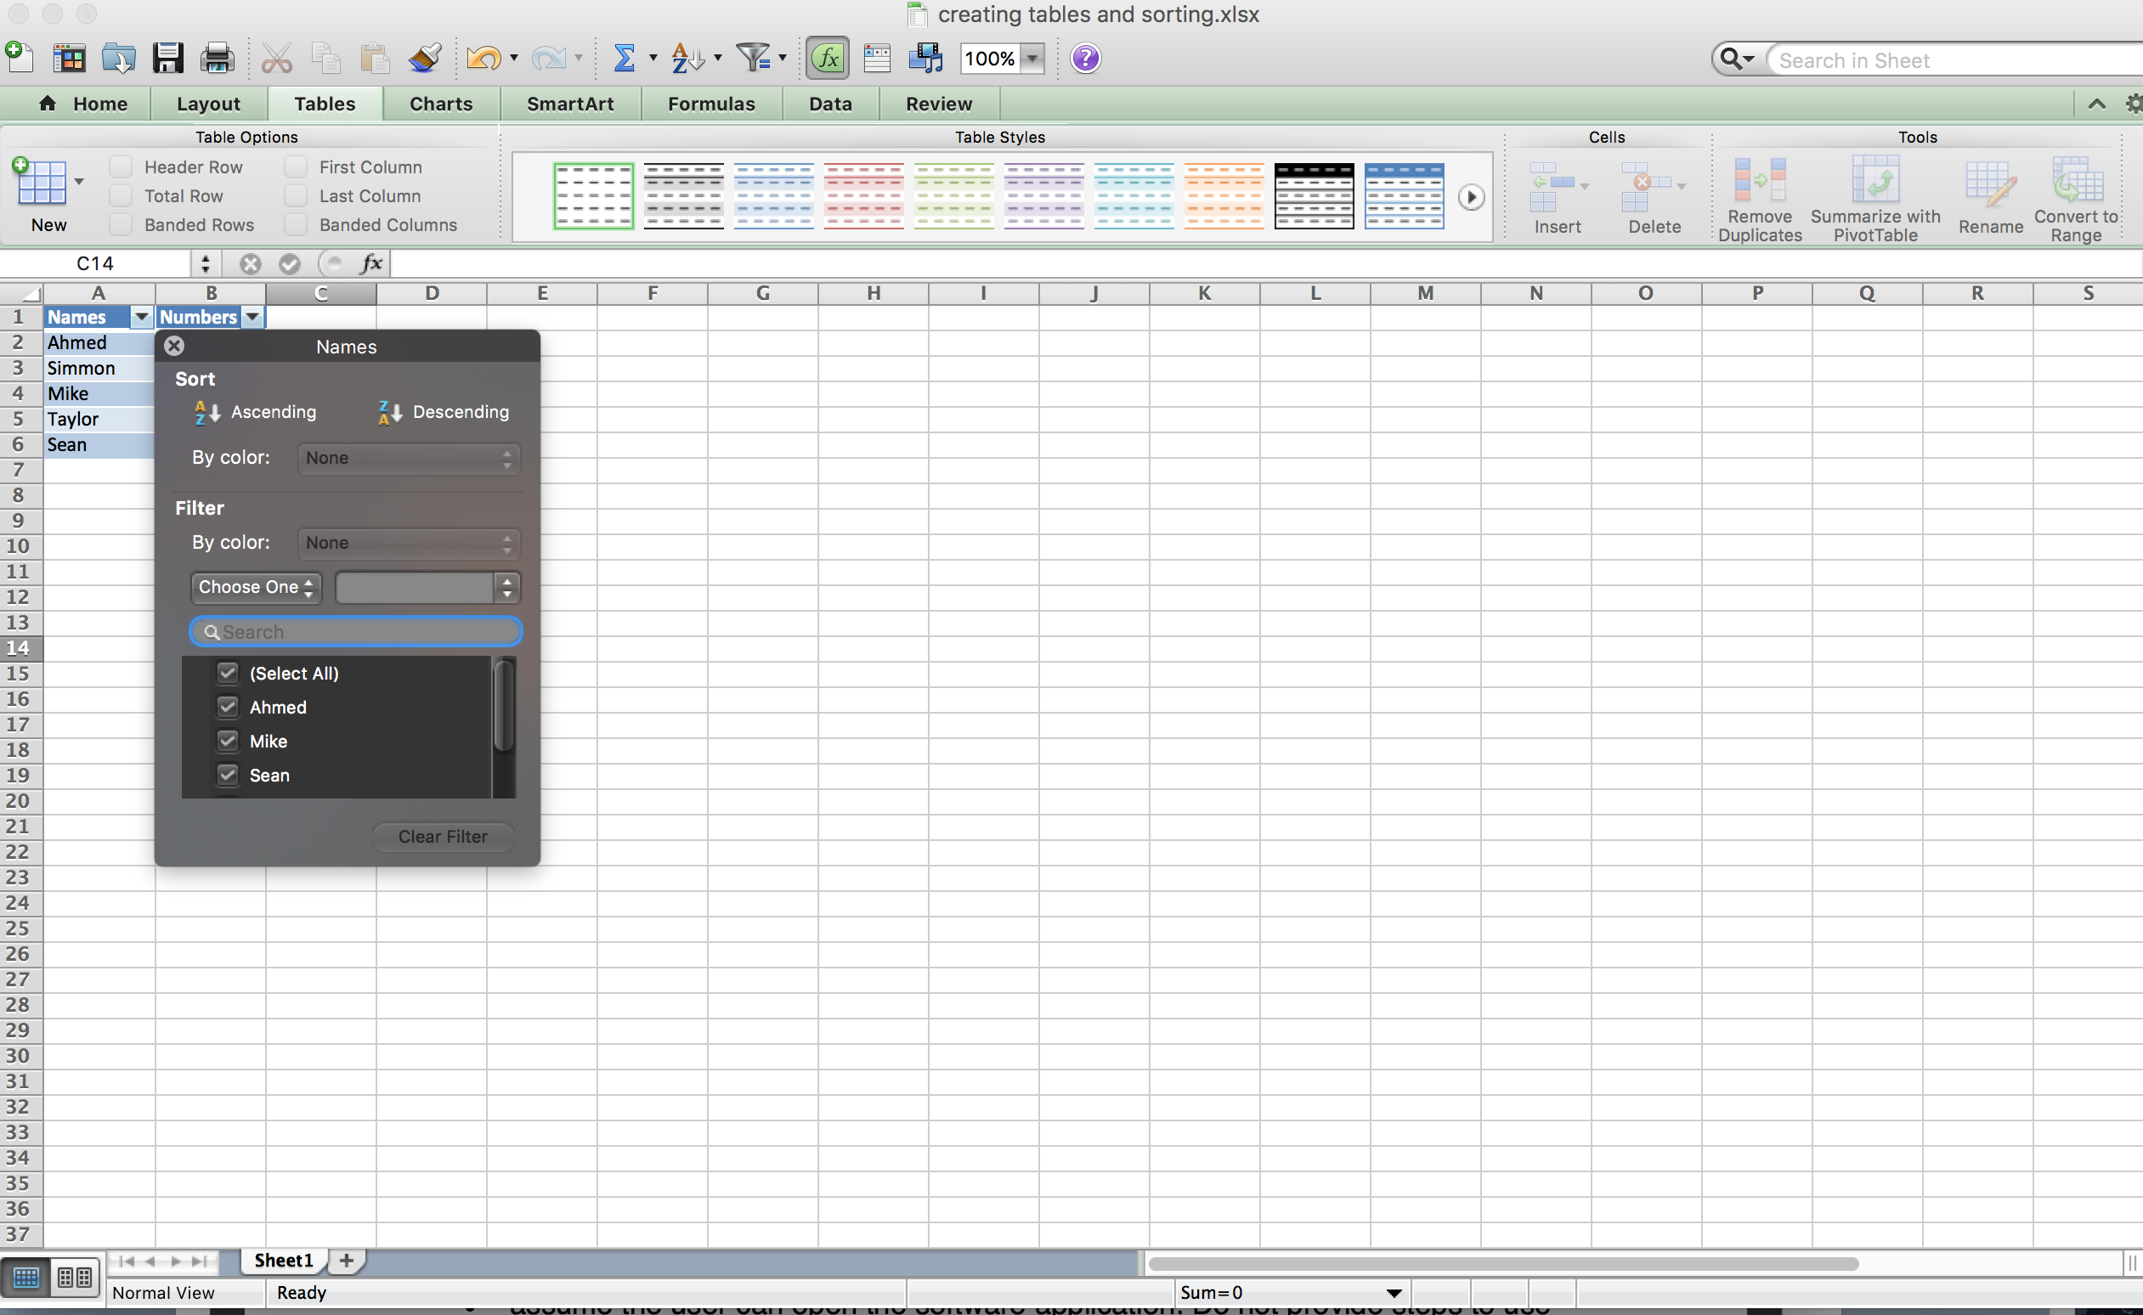

Fig 8: Using the sorting option to sort data inside a table

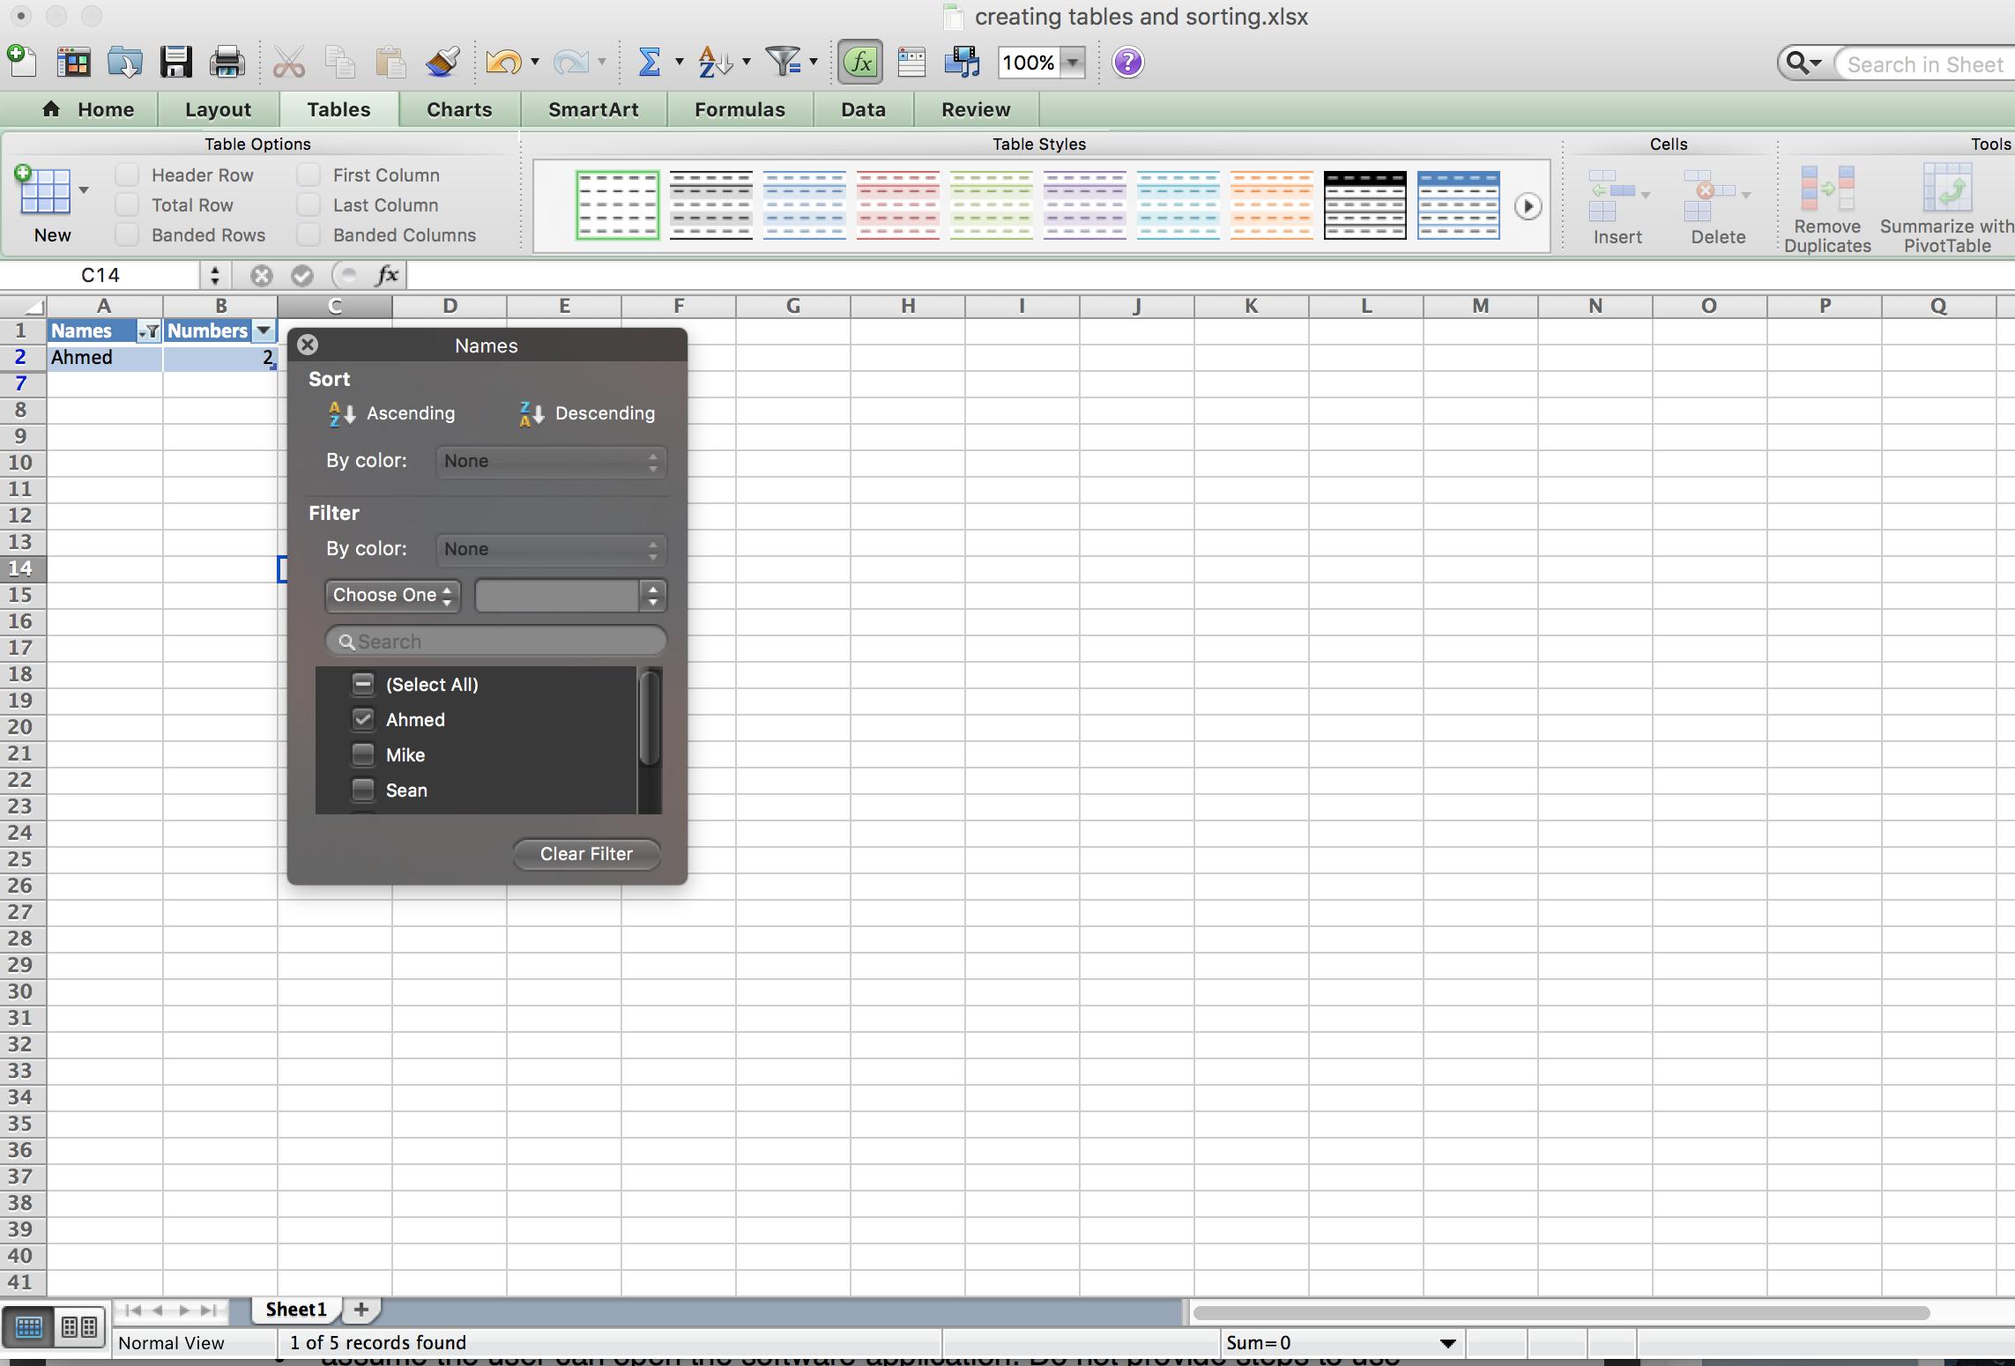

Fig 9: Displaying the sorted data inside an Excel table

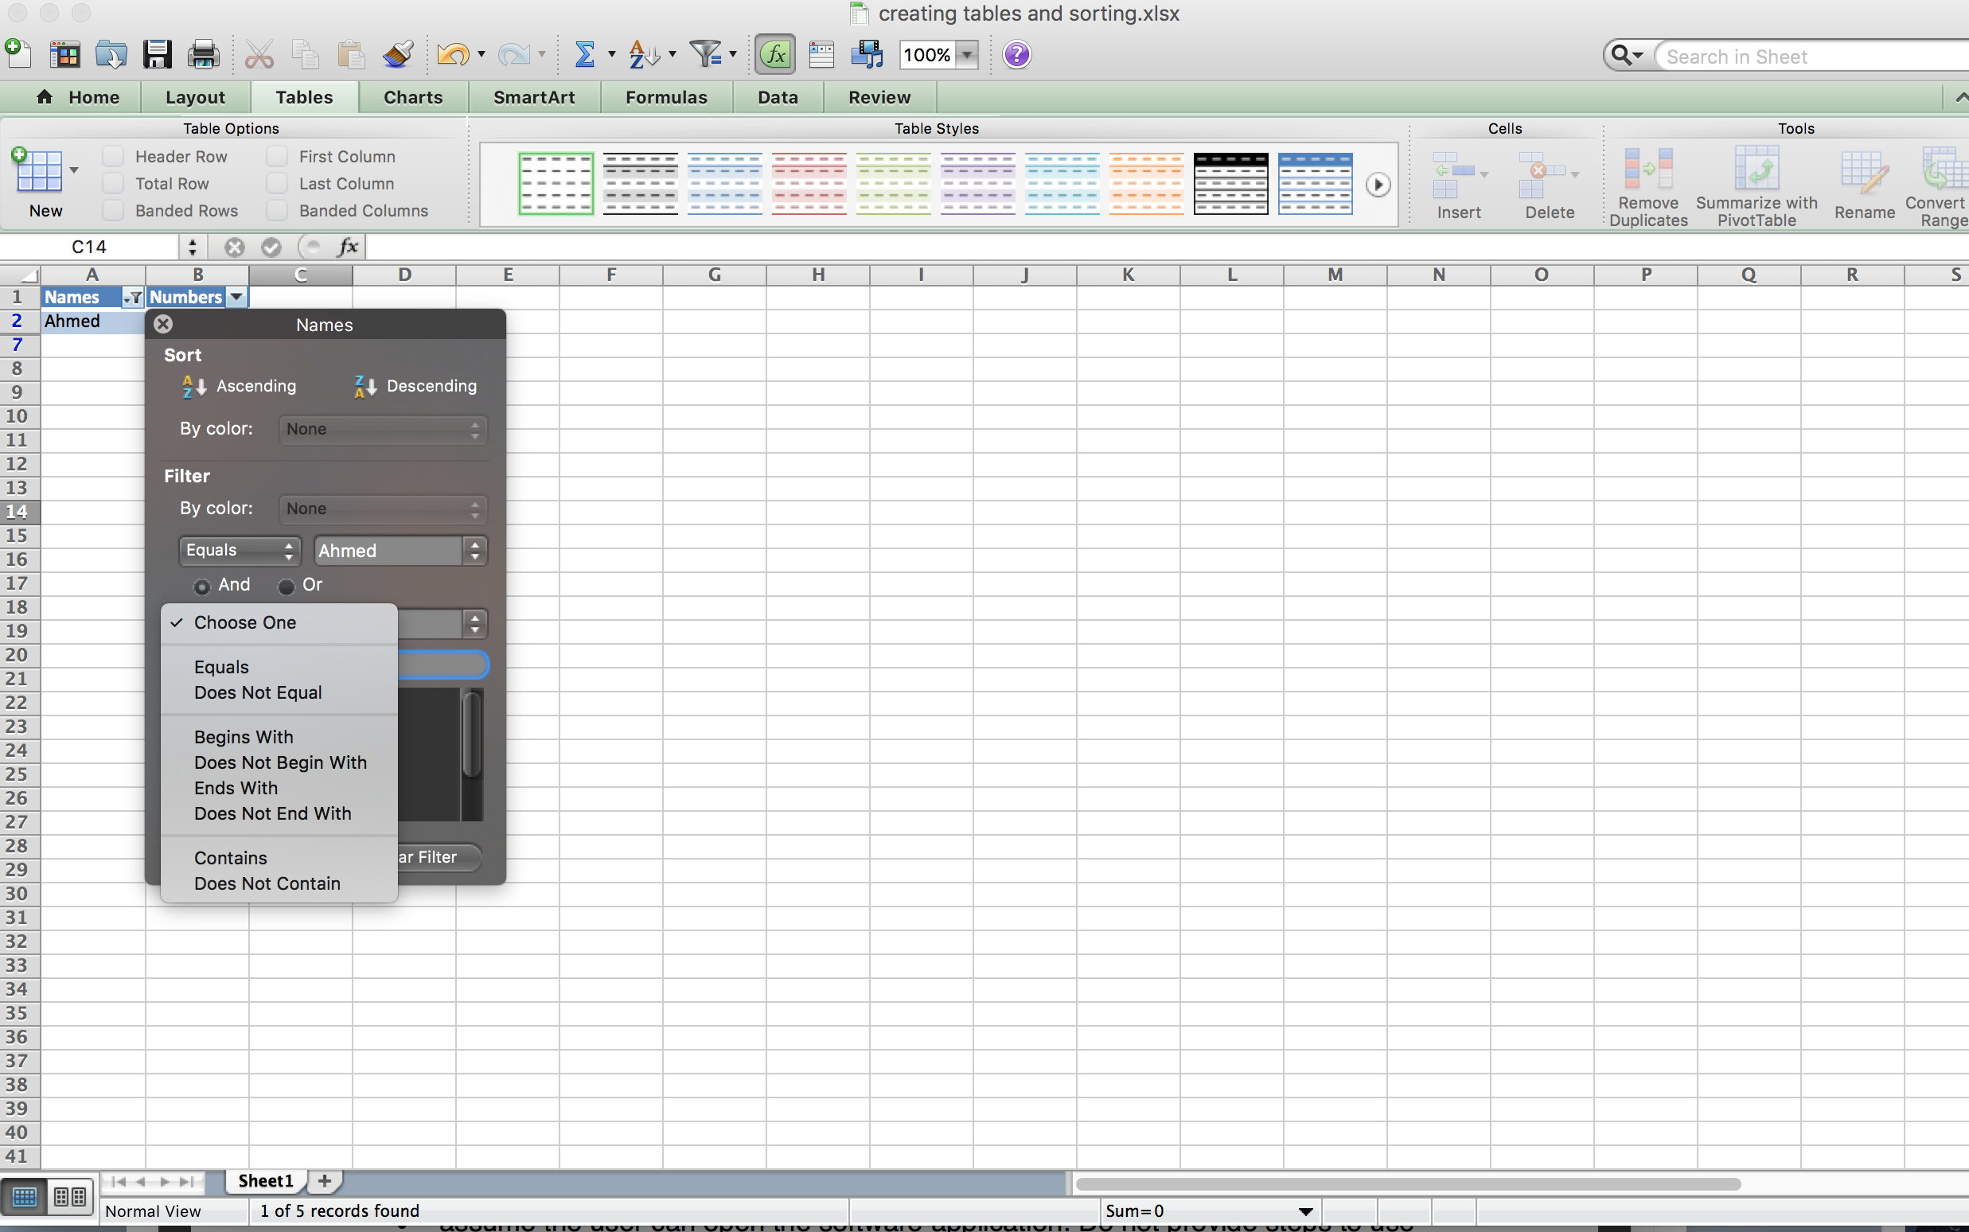

Fig 10: Displays other sorting options for the table content

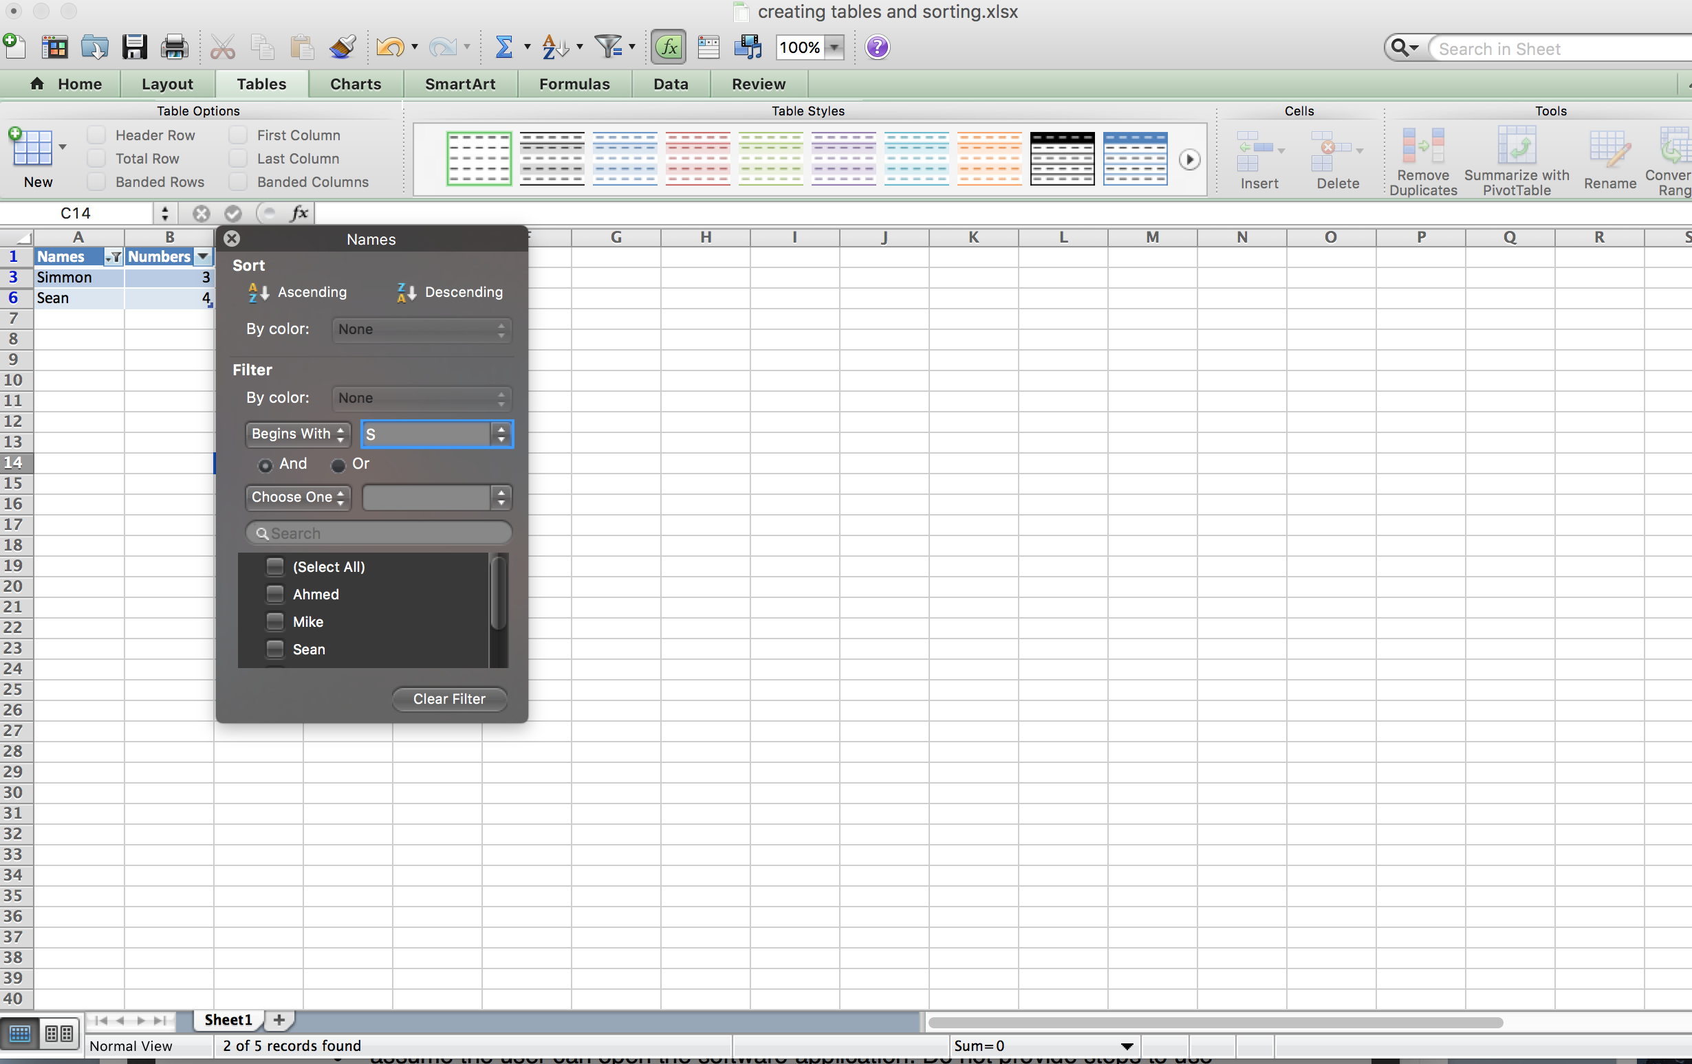

Fig 11: Displays the results of sorting data in a table using the “Filter” option in Excel

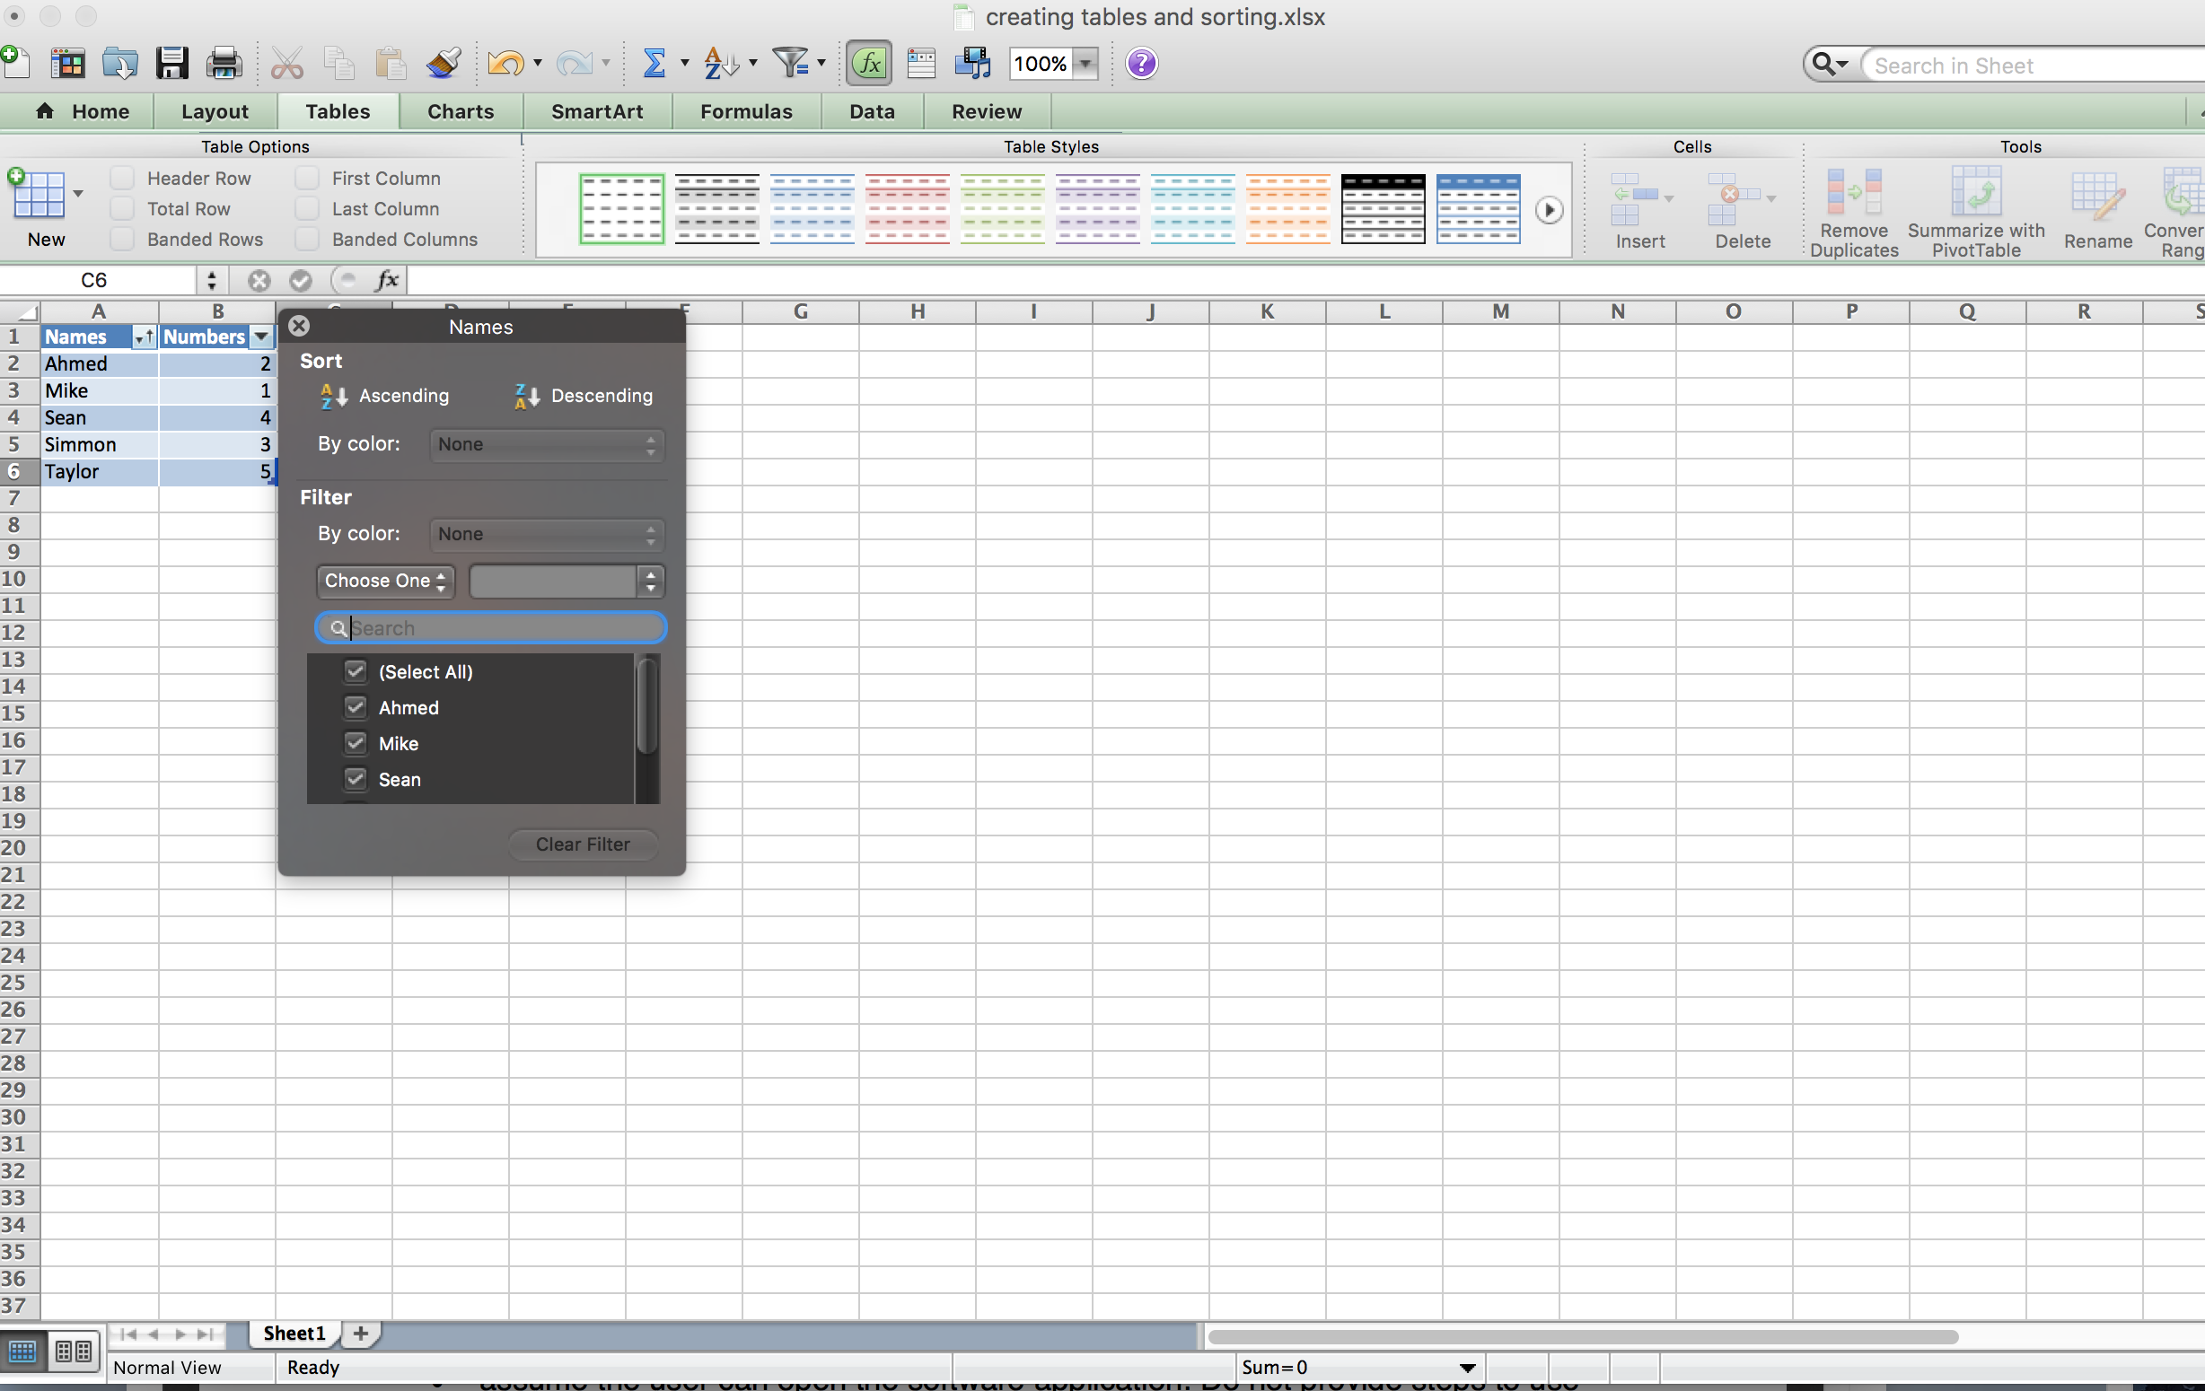

Fig 12: Clearing the filter option and sorting column in ascending order

Conclusion

In conclusion we can see that Excel table creation and sorting is one of the powerful tools that help Excel users to sort and filter any data according to the user’s requirement. With big data, we can see how the sorting and filtering be efficiently performing to achieve the user’s tasks and save time and money.